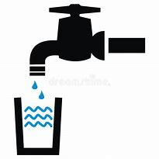 Raywood Water Supply Corporation
PO Box 125
Raywood, Tx 77582
Phone: (936) 587-4505
Fax # (936) 587-5000
Website: www.raywoodwater.com Email: raywoodwsc@aol.com

CUSTOMER INFORMATION UPDATE REQUEST

In an effort to most efficiently communicate with our customers, we ask that you take a few moments to complete the following information. It will be kept private and confidential.

Customer Name: ___________________________________________________________Acc#________________

Service Address: _______________________________________________________________________________

City: ________________________________________________State: _____________Zip Code: ______________

Description of Home:____________________________________________________________________________

Mailing Address: (if different) ____________________________________________________________________

City: ________________________________________________State: _____________Zip Code: ______________

Home Phone: __________________________________Cell Phone: _____________________________________

Email: _______________________________________________________________________________________

We offer free alerts, such as boiled water notices, etc. to customers who subscribe to our website. If you would like to be a subscriber, please indicate by checking below*

Alert by: *Cell phone _____ or *Email_____ or *Cell phone & Email_____

*If by cell phone indicate your service such as Verizon, etc._____________________________________________

Call: OR Mail to:
(936) 587-4505 Raywood Water Supply Corp.
PO Box 125
Raywood, Tx 77582
SEND COPY

Fax to: OR Email to: OR Text to:
(936) 587-5000 raywoodwsc@aol.com (936) 776-2981

